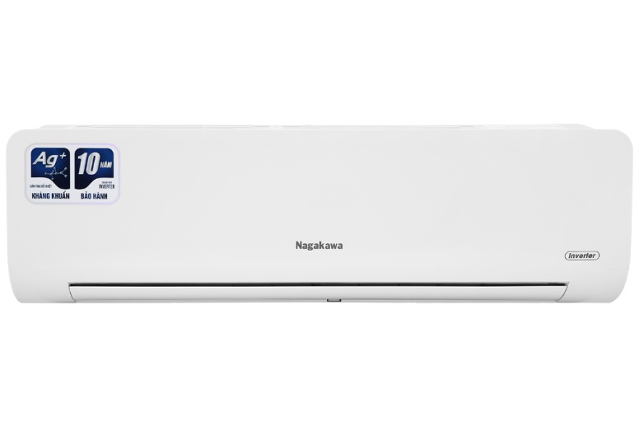

**9.420.000₫**

~~10.990.000₫~~ (-14%)Get an additional 1 year genuine warranty (Total 3 years)

**Technical specifications of Nagakawa Inverter 1.5 HP NIS-C12R2H10 air conditioner**

* Machine Type:

1 way (cooling only) With Inverter

* Cooling capacity:

1.5 HP - 12,000 BTU

* Effective cooling range:

From 15 - 20m² (from 40 to 60 m³)

* Dust filter, antibacterial, deodorant:

5-layer integrated air cleaning system

* Power saving technology:

EconomyInverter

* Rapid cooling:

Super

* Utilities:

Smart operating mode Smart Sleep operating mode Dehumidifying function Self-cleaning function 4D air swing function iFeel temperature sensor Blue Fin radiator with antibacterial Ag+ ion coating Super quiet operation Quiet Turn-on timer Turn off the machine The temperature display screen on the indoor unit Remote has an LED light. Automatically restarts when power is restored

* Power consumption:

1.22 kW/h 5 stars (Energy efficiency 4.66)

* Cooler:

Length 82.2 cm - Height 25.8 cm - Thickness 20.3 cm - Weight 7.5 kg

* Outdoor:

Length 72 cm - Height 48.2 cm - Thickness 25.7 cm - Weight 22.5 kg

Introducing the company 

- Vietnamese brand.  
- Established in 2002.  
- Diverse business products: air conditioners, dishwashers, induction cookers,.... with product prices easily accessible to consumers.  
- Achieved many outstanding achievements: Top 100 best products for families and children (2023), golden brand for Vietnamese health (2019),.

**Sterilize and deodorize thanks to the Auto Clean self-cleaning function**

[Nagakawa Inverter 1.5 HP NIS-C12R2H10 air conditioner](https://www.dienmayxanh.com/may-lanh/nagakawa-nis-c12r2h10) thanks to the Auto Clean self-cleaning function will effectively remove bacteria and mold up to 99.9% and dry water remaining in the radiator.

[The self-cleaning function](https://www.dienmayxanh.com/kinh-nghiem-hay/tu-lam-sach-tren-may-lanh-la-gi-1070640) has the main effect of cleaning, eliminating the breeding environment of pathogens, creating a fresh atmosphere. At the same time, it increases the life of the air conditioner and saves on cleaning costs for the family.

**Fresh air with 5-layer air cleaning system**

Air cleaning system with 5-layer filter membrane, this membrane has the main effect of cleaning the air thanks to the filter removing agents that have a negative impact on health such as bacteria, dirt, mold... The most effective way.

**Inverter technology saves electricity, operates smoothly and stably**

NIS-C12R2H10 air conditioner applies modern Inverter technology, operates smoothly and durable. The temperature in the room is always maintained at a stable level, significantly reducing your monthly electricity costs.

In addition, the Economy energy saving function integrated into [the air conditioner](https://www.dienmayxanh.com/may-lanh) also contributes to optimal energy savings.

**Smart temperature sensor on I Feel remote**

[The Nagakawa air conditioner](https://www.dienmayxanh.com/may-lanh-nagakawa) 's remote   is integrated with an I Feel smart temperature sensor. This sensor's main function is to transmit signals to the indoor unit about the temperature in the surrounding environment where the remote is located that it senses.

Therefore, you just need to place the remote next to your body to enjoy the cool air flow as desired.

**Modern design, suitable for rooms with an area of ​​15 - 20 m2**

Nagakawa Inverter NIS-C12R2H10 air conditioner has a modern design with luxurious white tones, suitable for all home interior spaces.

With a cooling capacity of [1.5 HP](https://www.dienmayxanh.com/may-lanh?g=15-hp) , the Nagakawa air conditioner is suitable for areas from 15 - 20 m2.

**Instant and fast cooling with Super mode**

Super mode will enhance the performance of the air conditioner as soon as this mode is activated, to achieve a fast cooling speed, providing an instantly cool atmosphere without having to wait long.

**The space is dry and airy thanks to the dehumidifying feature**

[The dehumidifying feature](https://www.dienmayxanh.com/kinh-nghiem-hay/cac-che-do-thuong-thay-tren-may-lanh-795107#hmenuid6) will be suitable on days of humid weather and high air humidity. Thanks to its ability to reduce moisture in the air, returning the space to a dry, comfortable space.

***Note:****The dehumidifying feature only helps reduce humidity in the air and does not have a cooling effect.*

**Easily monitor temperature at night with LED temperature display**

With a gentle LED display on the indoor unit, at night you will easily monitor and adjust the temperature of the machine instead of having to use a light to check the temperature on the remote and then adjust it like some conventional air conditioners. often.

**Increase cooling performance with 4D air swing mode**

4D air swing mode allows the flap to swing the air vertically (up/down) and horizontally (left/right) to help create cold air flows that spread evenly everywhere in the room.

**Convenient auto-restart function when power is restored**

[Thanks to the auto-restart](https://www.dienmayxanh.com/kinh-nghiem-hay/che-do-hen-gio-va-tu-khoi-dong-khi-co-dien-lai-co-588231#hmenuid3) function when power is restored , the air conditioner will automatically remember the operating settings before the power is suddenly cut off. When there is power, the air conditioner will automatically start according to previously memorized parameters.

Therefore, you do not need to spend a lot of time resetting the parameters for the air conditioner to operate.

**BlueFin green-plated heat exchanger is anti-corrosion and anti-fouling**

The heat exchanger of Nagakawa air conditioners is covered with a blue BlueFin layer that effectively prevents corrosion and stains, limits the effects of harsh weather, and increases resistance and durable use.

Overall, the Nagakawa Inverter 1.5 HP NIS-C12R2H10 air conditioner is a suitable air conditioner for households that need to cool a room area of ​​15 - 20 m2. With many convenient modes, besides saving electricity and cooling quickly, the air conditioner will bring great experiences when used.